**COST ANALYSIS OF FOOD ORDERING SYSTEM**

**Cost Analysis:**

Cost analysis of a project is basically stands for the act of breaking down a cost summary into its constituents and studying and reporting on each factor. The actual purpose of the comparison of costs for disclosing and reporting on conditions subject to improvement of the project.

The information obtained during a cost-benefit analysis makes budgeting easier. If all the possible costs listed, one can project the budget needed to undertake the project. The anticipated benefits can also be used to project sales if they can be quantified into financial goals. Both considerations are useful when preparing budgets and sales projections.

**Main Items That Determine an Ecommerce Websites Cost:**

Design - There is a big different in cost for a fully custom design vs. a template

Custom Functionality needs and unique programmed features will increase pricing

Data Imports - Do you need product date or past order / customer data imported?

Marketing - A fully integrated marketing plan will boost the cost of the build

Integrations with an ERP or other 3rd parties often cost thousands

If the project is being outsourced overseas, it will be less expensive

**Design:**

To analyses cost for a website we have to consider how the website will look. So we choose COCOMO model design for our website. In COCOMO model we choose basic model that is used to rough fashion, small or medium size project. The first impression is everything, and it's important that the look matches someone expectation in sales. An amateur looking website will convert visitors into customers at a much lower rate than a professional custom Ecommerce website. Also, consider branding. If you have a large established brand, the website should reflect this. On the web, people will get one shot to impress, so many Ecommerce owners spend big bucks making a site that sells based on the way it looks. If we're in need of a website that will be responsive, meaning optimized for mobile and tablet, a design will also need to be created for those devices which add additional time to a project.

The low-cost route is using a pre-made template or design. This means the design is already done and our logo or colors may be included into it.

**Project description:**

Now we can design our website and analysis from that how much cost is needed for our project.

Our project is basically based on creating a website for fresh food ordering. To startup our project we need some basic equipment. Like:

An office that is must to work together and also some furniture’s to setup the look of the office. A Caretaker who will look after the office, materials and so on.

Website customized with unique logo which is free of cost, attractive color theme and beautiful images, simple CMS, eye catching slider, easy navigations, pleasing UI/UX, Gallery, Responsive web design and payment method . Free domain/hosting is for 6 months. Free two months webpage maintenance. After two month, the client must pay 30,000 per month.

The chart of Cost analysis for our required things to start our project is given below:

|  |  |  |  |  |
| --- | --- | --- | --- | --- |
| Work Description | Quantity | Month | Cost (per month) | Total Cost (Taka) |
| Office and Administration Expenses: |  |  |  |  |
| 1.Office rent |  | 6 | 25000 | 1,50,000 |
| 2.Furniture |  |  | 50000 | 50,000 |
| 3.Computer | 6 |  |  | 2,50,000 |
| 4. Developers | 7 | 6 | 25000 | 10,50,000 |
| 5.Host cost | 1 | 4 | 10000 | 40000 |
| 5.Other employees |  |  |  | 1,00000 |
| Billing cost: |  |  |  |  |
| 1.Telephone | 7 | 6 | 700 | 29,400 |
| 2 Internet |  | 6 | 1600 | 9,600 |
| 3.Utilities |  | 6 | 6000 | 36000 |
| Developing Cost: |  |  |  |  |
| 1.Dynamic Pages | 15 |  |  | 50,000 |
| 2. CMS | 1 |  |  | 10,000 |
| 3. SEO friendly | 1 |  |  | 8,000 |
| 4. Responsive Design |  |  |  | 10,000 |
| 5. Payment Gateway |  |  |  | 30,000 |
| 6.Other activities |  |  |  | 50,000 |
| Total |  |  |  | 18,73,000 |

**Cost analysis Pie Chart:**

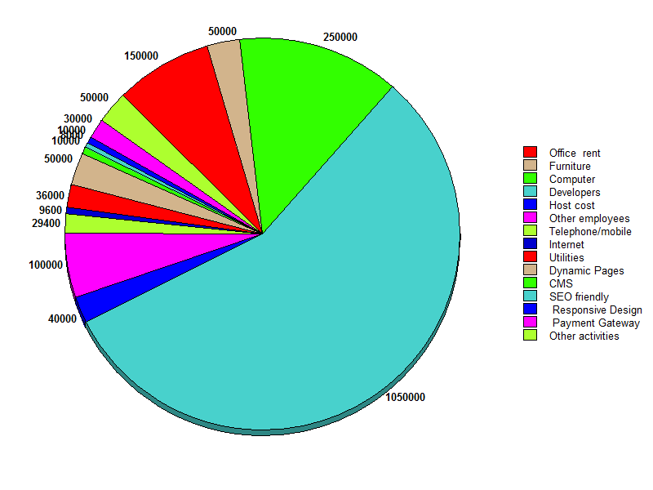

**Figure: Pie chart of cost analysis of Food ordering system**